**Git stage practical session**

* Create a local repository
* create an empty directory and execute git init  
  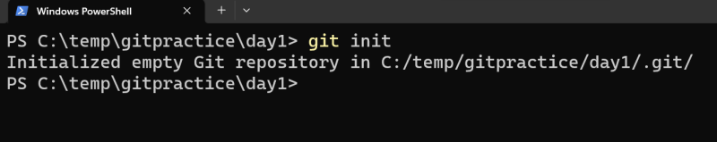
* Configure username and email id one time job  
  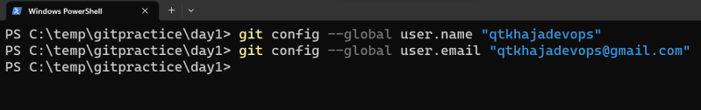
* Create one file one.txt and execute git status  
  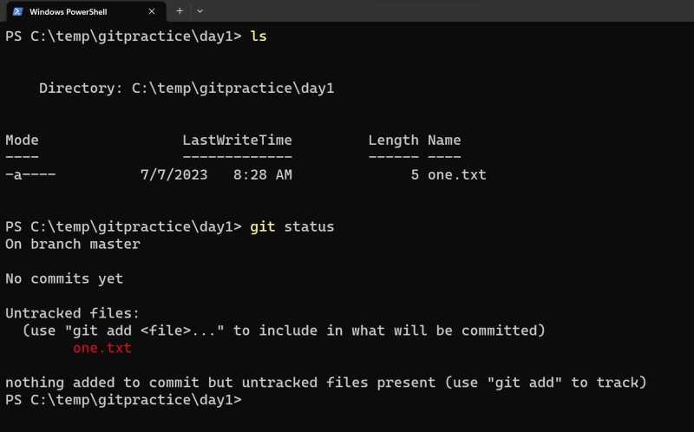
* Three areas quick revision  
  
* Let’s add this change to the staging area  
  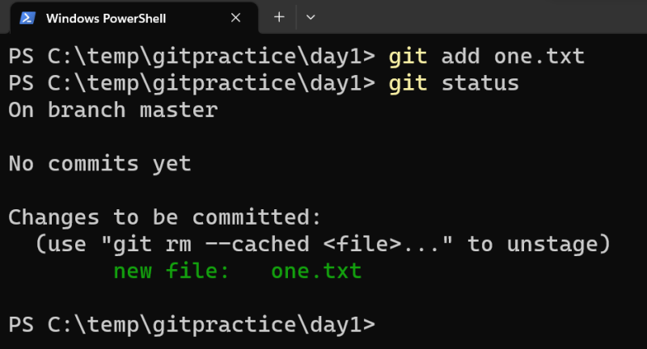
* Lets create a commit with this one change  
  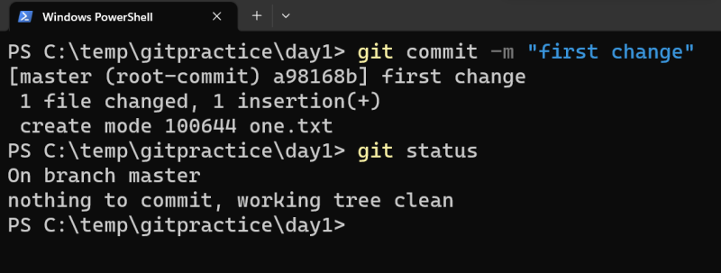
* For every commit git gives commit id with username, email, message and date time information  
  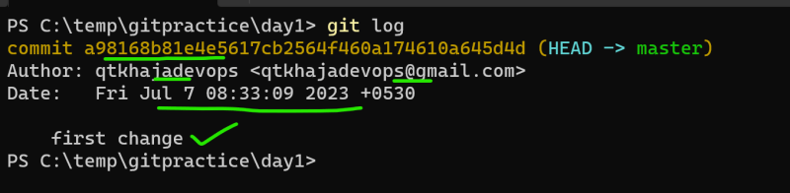
* Create a new file two.txt and change the contents of one.txt  
  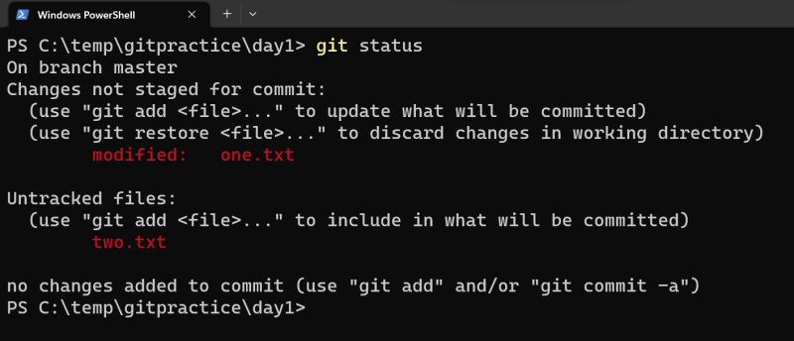
* untracked files represent the files newly created in working tree which donot have any history in local repo and for the files which are already existing in local repo we see states such as
  + modified
  + renamed
  + deleted
* Lets add both the changes to staging area  
  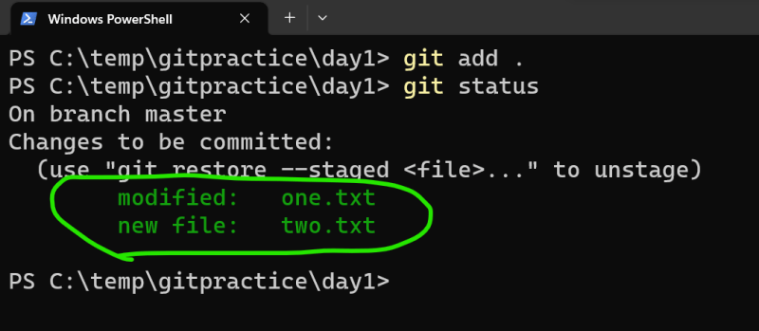  
  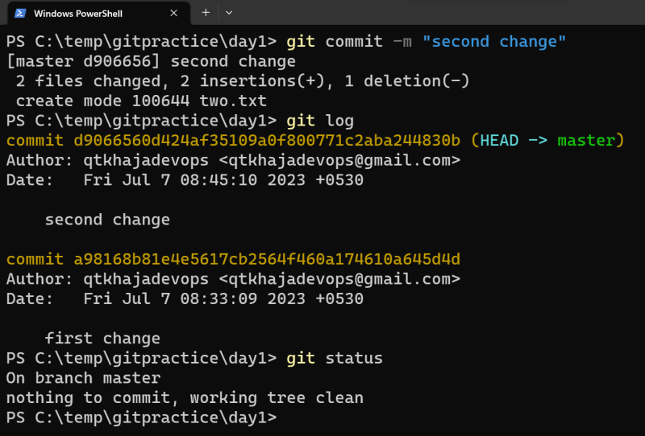
* Current work tree. By default, git always shows the content of the latest commit in working tree  
  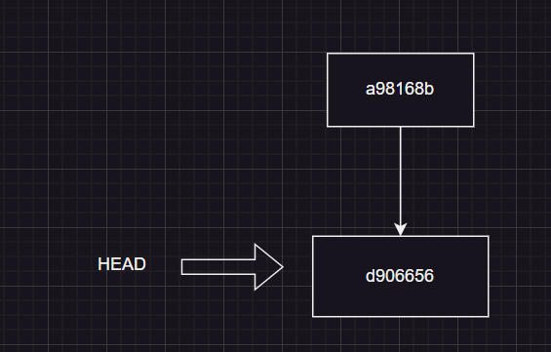
* Lets move back to history i.e first commit  
  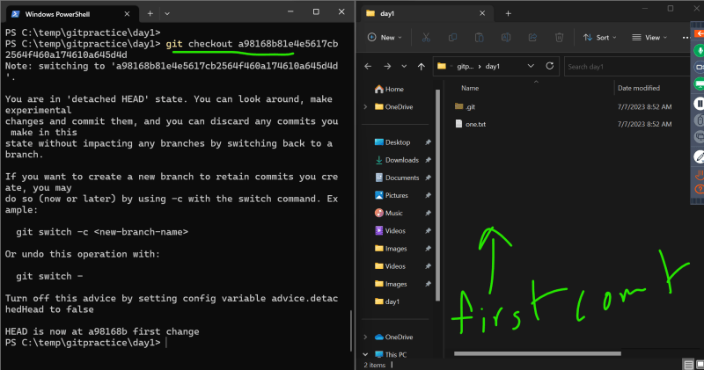  
  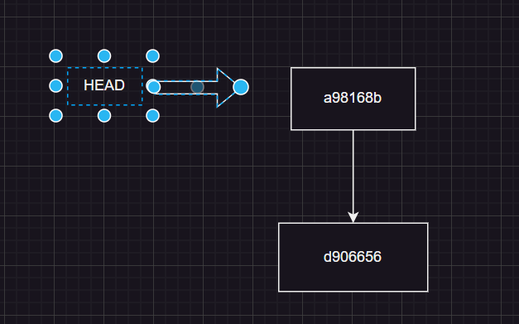
* Let’s go back to latest commit git checkout master  
  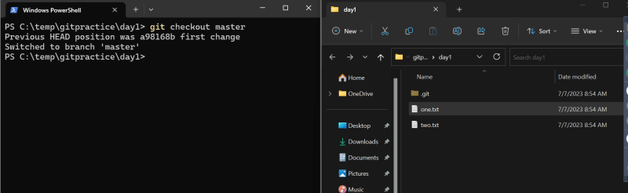  
  
* Lets move two.txt and one.txt to a new folder called as docs and commit the changes  
  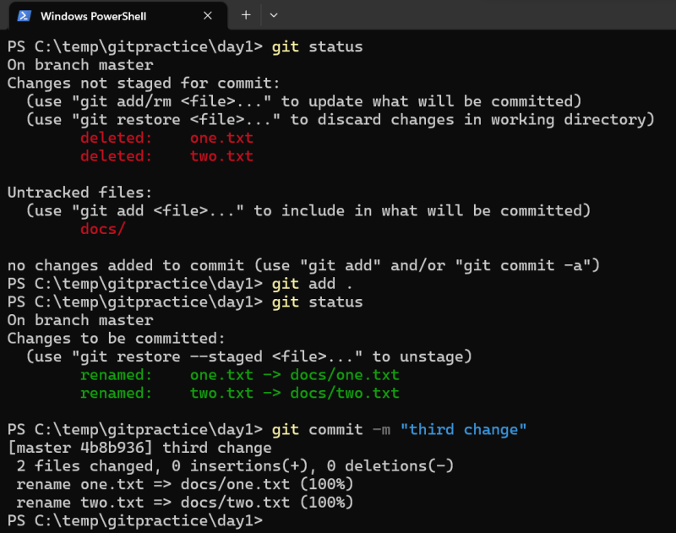  
  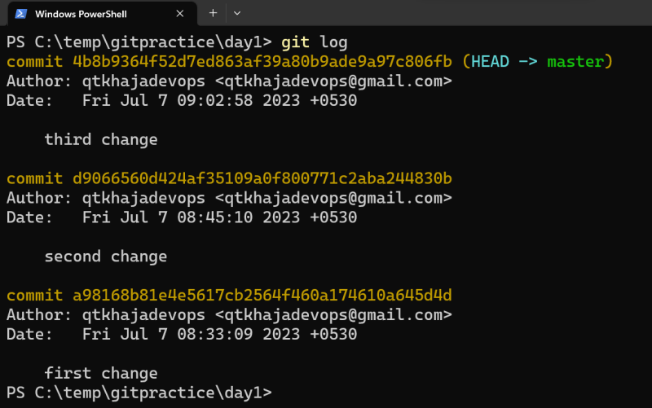  
  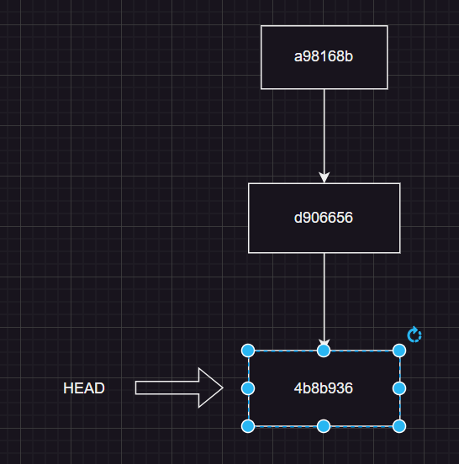

**Commands**

* init: this initializes a new repository
* add: adds the changes from working tree to staging area
* status: shows the status of working tree and changes
* commit: this command commits the changes from staging area to local repository
* log: shows the commits done in local repo

## **LAB1:**

* Lets initialize the new repo in a local system
* Add 3 commits into the repo
* git add comes with 4 major options for adding changes
  + git add
  + git add . adding all the changes relative to current directory
  + git add -A add all the changes
  + git add -u add only modified files
* Add the changes to staging area try to unstage  
  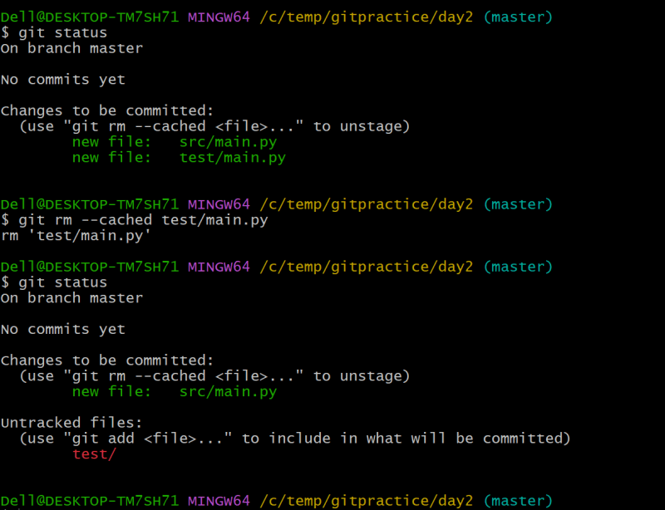
* To unstage the popular option is git restore –staged
* To remove the changes from working tree
  + modified: git restore
  + untracked:
    - delete normally
    - git clean -fd .

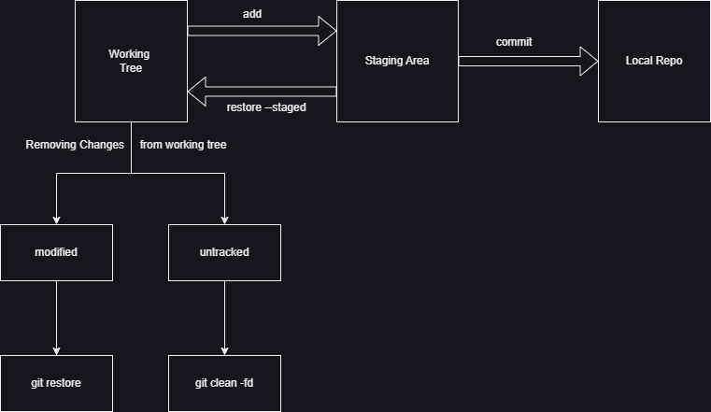

Exercise: What is soft reset vs hard reset

git reset --hard

git reset --soft

